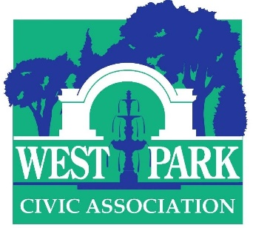

45th Annual Art-in-the-Park
Saturday June 15, 10 A.M. to 5 P.M. (rain or shine)

Application
New classification: Hors Concours
Artists who have exhibited the past two years and have been long-time exhibitors are deemed Hors Concours, meaning that they are automatically accepted and do not have to undergo the vetting process. Please notify us if you feel that your application falls into this classification. If you have any questions about whether you qualify for Hors Concours, just ask.

Application process
Please email six clear low- or medium-resolution color images of artworks along with your name, mailing address, and telephone # to Dr. Christine Isabelle Oaklander at drokie16@gmail.com. If you have a website, please provide the url. Deadline for applications: May 15. Notification: rolling admissions, latest notification June 1. Your commitment to exhibit must be received by June 7.

Who may apply
Accomplished, original artists from all ages and backgrounds (trained and untrained) are encouraged to apply. Applications will be vetted by Dr. Margo Hobbs, Associate Professor and Chair of the Art Department, Muhlenberg College and Ilene Hochberg Wood, aesthetic trendsetter and prominent art patron. There is no application fee.

Mediums accepted/Prizes
Acceptable mediums include sculpture, painting, works on paper (drawings, photographs, collage, prints) and crafts (woodworking, ceramics, fiber art, jewelry etc.). Cash prizes will be awarded in various categories. Our judges are Dr. Kathleen Jameson, the new Executive Director & CEO, James Michener Art Museum and Scott Schweigert, Curator of Art & Civilization, Reading Public Museum.

Exhibitor fees, dates, and other information
An exhibitor fee of $65 for a 25-foot space is due by June 7, 2019. If you have a favorite spot, please say so up front. No commercial galleries or representatives are permitted. The artist must accompany his/her exhibit—or arrange for a pre-approved substitute—to interact with the public. Two or more exhibitors may share a space by pre-arrangement, but the entry fee must be paid by each exhibitor. Display screens consisting of 2 hinged panels (total area 52” x 63”) are available first-come first-served for a fee of $10 each; limit 3 screens. Refunds will only be given if the show is cancelled. Please send checks for entry fee and screens made out to West Park Civic Association, noting in the memo section that the payment is for Art-in-the-Park. Mailing address: 19 S. Franklin Street, Allentown, PA 18102 Attention: AITP

Sales
Exhibitors are permitted to sell their works; there is no commission. However, you are responsible for all transactions; the WPCA cannot make change or facilitate sales. The show will be promoted through online and press media. A program listing exhibitors will be distributed on the day of the show. Please email Dr. Christine Isabelle Oaklander at drokie16@gmail.com with any questions.

